SEPTEMBER 2021
FAITH, TRUST & COMMUNITY
FOR COUNTRYSIDE TRINITY CHURCH
Mission Study

TABLE OF CONTENTS

Countryside Trinity Church | 1
Vision and Mission | 2
History Of Countryside Trinity Church | 3
Context and Demographics
Congregation | 5
Neighborhood | 6
Community | 7
Physical Resources | 8
Ministry Resources | 9
Goals | 10
Moving Forward | 11
Prepared by: | Debra Davis
 | Dan Groom
 | Mari McKenzie
 | Mary Ann Parker
 | Roger Scovill
Approved by Session: | October XX, 2021

COUNTRYSIDE TRINITY CHURCH

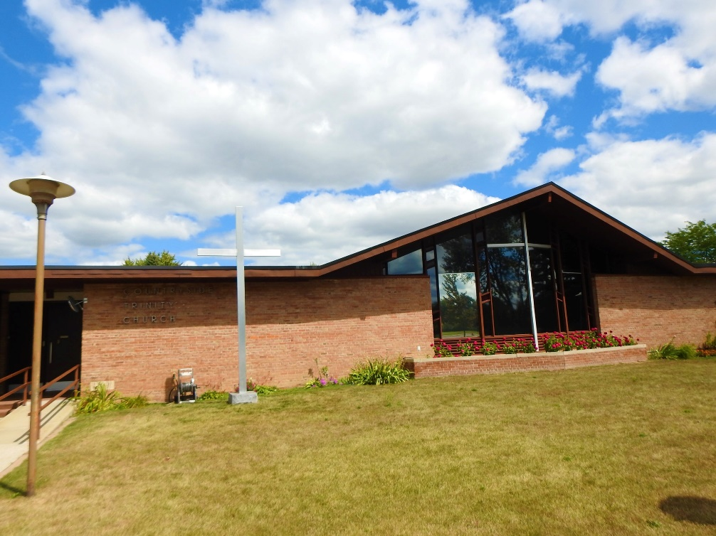

AFFILIATION
Presbyterian Church (U.S.A.) & United Church of Christ

No matter where you are in life’s journey …
All are welcome here!

VISION

Engaging the Gospel...
that heals hearts
and creates communities.
Seeking the Spirit
to know God
and embrace humanity.

MISSION
COUNTRYSIDE TRINITY CHURCH

Connecting to Christ…

Telling our story…

Caring beyond ourselves…

HISTORY OF COUNTRYSIDE TRINITY CHURCH

1853 | A member of First Presbyterian Church on the west side of Saginaw starts a Sunday School located at S. Jefferson and Hoyt Streets.
1865 | A group of women begin a Sunday School in South Saginaw, Washington Avenue.
1866 | On November 10th the Presbyterian Church of South Saginaw is formally organized.
1867 | After worshipping several years with the Congregationalists, the Baptists, and Presbyterians at a Federal Street location, thirty-six people form the First Presbyterian Church of East Saginaw on March 24th.
1874 | Seventy-six members worship in a newly constructed brick building at the corner of Warren Avenue and Millard Street.
1885 | A brick church is erected at the corner of Washington Avenue and Williamson Road. The cities of East Saginaw and South Saginaw are consolidated, and the church becomes known as Washington Avenue Presbyterian Church.
1885 | First Presbyterian Church purchases a chapel in the 1400 block of Fayette from the Baptist Church in Saginaw.
1886 | First Presbyterian Church hires a minister to do missionary work in the area around the chapel.
1888 | The chapel is officially organized as Grace Presbyterian Church.
1891 | The brick Sanctuary building is completed for Grace Presbyterian Church.
1892 | The name of the First Presbyterian Church East Saginaw is changed to Warren Avenue Presbyterian Church.
1951 | “Memorial Hall” is built adjacent to Warren Avenue Presbyterian Church and is used for educational, social, and recreational activities.
1953 | Warren Avenue Presbyterian grows so much that they hire two pastors and have two services on Sunday morning.
1957 | A group known as Countryside Mission meets for worship at the Saginaw Township Hall.
1958 | On March 30th Countryside Mission formally organizes as Countryside Presbyterian Church with 110 charter members and worship services are moved to Hemmeter School Auditorium.
1959 | Worship services are moved to Weiss School Auditorium and construction begins on a new church building. Saginaw Presbytery provides land and long-term loan from Board of National Missions.
1959 | Ground is broken for new church building on Weiss Road.
1960 | On January 30th the cornerstone of the church is placed. The congregation moves to the 4690 Weiss Street address, the present site of Countryside Trinity Church. Church School meets in an old farmhouse on corner of Bradford and Weiss. First and organizing pastor is the Rev. David Ernsberger (1959-1961).
1967 | An education area is added. The United Community congregation of the United Church of Christ begins meeting, working, and worshipping with the Countryside Presbyterian Church congregation.
1969 | On September 7th the United Church of Christ congregation and the Countryside Presbyterian Church congregation become a union church known as Countryside Church.
1978 | The first clergy couple for the Presbytery of Lake Huron is hired to serve as associate pastors, each half time, for Warren Avenue Presbyterian Church.
1982 | The mortgage for Countryside Church is burned on January 31st.
1996 | A committee is formed of members from Washington Avenue Presbyterian Church and Countryside Church to make plans for their two congregations to become a union church.
1998 | On January 4th, Washington Avenue Presbyterian Church hold their last worship service, and the congregation moves to Countryside Church on the same day. The two congregations become a union church known as Countryside Trinity Church.
2000 | Grace Presbyterian Church has its last worship service. Individuals move their memberships to several other churches. A significant number of members join Countryside Trinity Church.
2003 | On April 23rd, a loan is obtained to build a new educational addition to the west end of the church. Our five-year-old congregation has grown together in loving and serving the Lord. Being a Union Church has given us many opportunities to learn and serve. A long journey has been worth the effort.
2004 | Congregants at Countryside Trinity Church give generously. The loan is paid off on December 29th.
2018 | On November 25th, Warren Avenue Presbyterian Church hold their last worship service, and a decommissioning service is held. On December 9th, a significant number of members from Warren Avenue are welcomed and blended into the membership of Countryside Trinity Church.
2021 | The Deerfield property with the manse is sold on February 4th.

Our journey in worshipping, discerning His will for us, and serving the Lord continue as our history together grows and flourishes.
CONTEXT AND DEMOGRAPHICS
CONGREGATION

- The congregation is made up of 120 members and several friends as of 9/30/21.

- The majority of members 51% are over 70 years old.

- The majority of members 66% are female.

- The majority of members 96% are white.

- The majority of church families 76% live within the 48602, 48603 and 48638 zip codes.

CONTEXT AND DEMOGRAPHICS
NEIGHBORHOOD

The neighborhood surrounding the church has comparable characteristics.
Based on 2021 Mission Insite Report, we can glean the following:
- A high percentage of neighbors 25% are over 65 years old.

- The majority of households 66% are married couples.

- The majority of neighbors 78% are white.

- 16% of the households earn less than $25,000 a year.

CONTEXT AND DEMOGRAPHICS
COMMUNITY

Countryside Trinity Church is located at 4690 Weiss Street, Saginaw, MI 48603 which is in Saginaw Township.
- Saginaw Township has a population of 41,679 people. (Based on 2020 US Census)

- The median age is 48. Twenty-three percent (23%) of the population are over 65 years of age. (Based on 2019 American Community Survey)

- The median household income is $51,680. Eleven percent (11%) of the individuals are living below the poverty level. (Based on 2019 American Community Survey)

- Twelve percent (12 %) of the children are living below the poverty level. (Based on 2019 American Community Survey)

- There are 3,791 businesses in Saginaw Township. Health care and retail trade have the highest number of establishments. (2015 US Census American Fact Finder)

CHURCHES NEAR COUNTRYSIDE TRINITY CHURCH
Church of God
Faith Baptist Church
Faith Evangelical Lutheran
First Free Methodist Church
Hopevale Church
Ministry Without Walls
New Life Christian Fellowship
Our Savior Lutheran Church
Seventh Day Adventist Church
St. Thomas Aquinas Catholic Church

PHYSICAL RESOURCES

COUNTRYSIDE TRINITY CHURCH IS DEBT FREE.
MEMBERS HAVE A HISTORY OF GIVING GENEROUSLY WHEN SPECIFIC NEEDS ARISE.

NEIGHBORHOOD
LOCATION is on a highly traveled street in a pleasing suburban neighborhood.
NEAREST NEIGHBOR is Weiss Elementary School across the street. A safety plan is in effect for the school to use our facility if an emergency at the school occurs.
MANY SENIOR HOUSING FACILITIES are nearby.

CHURCH COMPLEX
LARGE PARKING AREA which needs attention.
SURROUNDED by a beautiful large lawn.
STORAGE SHEDS at back of building.

BUILDING
BOILER was installed in 2014.

SANCTUARY
BEAUTIFUL SANCTUARY with ornate baptismal fount, pulpit, communion table, and three ceremonial chairs located on or in front of the chancel area. Banners and candelabras adorn each side of the centered large wooden cross.
AN ORGAN, TWO PIANOS, AND TWO KEYBOARDS are located within the church.
COMFORTABLE PEWS are formed in half circle around the chancel.

SANCTUARY – TECHNOLOGY
STREAMING VIDEO CAMERA capable of direct connection to the internet.
TWO (2) 72” MONITORS.
DESKTOP COMPUTER to enable audio visual displays on the sanctuary monitors.

FELLOWSHIP HALL
OPEN, SPACIOUS AREA for Sunday coffee hours, potlucks, luncheons, and Lenten/Advent gatherings.
EQUIPPED with large monitor with internet connection.
COMMERICALLY EQUIPPED KITCHEN.
BOTH AREAS are rented by our church families and outside groups.

EDUCATION ROOMS
FIVE SIZABLE ROOMS located in a wing directly connected to the church.
TWO ADDITIONAL ROOMS plus a nursery area located off the fellowship area.
ONE large lounge is used for adult study groups and meetings.
MINISTRY RESOURCES

CHRISTIAN FELLOWSHIP
OPPORTUNITIES abound for fellowship whether it is during Sunday fellowship hour, book study, potlucks, or soup suppers (for Lent and Advent). We treasure time together as we shop and pack food baskets, organize food back pack program at Weiss Elementary, prepare for the bazaar, and other projects.
FELLOWSHIP IS EXTENDED into our Christian education programs and committee work.
PRAYER CHAIN is made up of loyal participants.

MUSIC PROGRAM
COMPELLING MUSIC PROGRAM.
DIRECTOR OF MUSIC is devoted to his ministry and selects anthems with concentrated effort toward the skills and the size of the choir.
TALENTED PIANIST/ACCOMPANIST.

CHRISTIAN EDUCATION
CHURCH SCHOOL PROGRAM is inactive. COVID-19 has put a pause on Christian Education. Programs will be revamped and restored as the environment permits.
DAILY DEVOTIONAL BOOKLETS are available to all.

MISSION
COMMUNITY MISSION GROUPS have a long-standing history with Countryside Trinity Church.
BOY SCOUT TROOP 304 is sponsored by the Church and provided a meeting space.
REPRESENTATIVES from the various agencies speak at our church periodically.
MEMBERS are encouraged to volunteer at the local missions to become more physically and spiritually involved.
WORLD WIDE MISSIONS are supported at various times of the year.

CHURCH STAFF AND VOLUNTEERS
DEDICATED STAFF and VOLUNTEERS keep the church running smoothly and efficiently, along with maintaining the building and grounds.

GOALS

- To share our personal faith journey with others and be comfortable in telling our story of how our faith gives us strength to be disciples of Christ.
- To be open and willing to accept change as we creatively work to develop enthusiasm and excitement for our church.
- To encourage members of the congregation to be involved inside and outside our church walls.
- To use our talents and skills to be a church that displays the love of Christ and connects with people of all walks of life.
- To continue to be a community of faith with gentleness, love and respect for others as we reach outside our walls showing compassion for all people and accepting those people where they are without judgement.
- To rekindle and expand our Congregational Care Team to help reach out to our church family and friends.
- To reestablish educational, spiritual and fellowship activities.

MOVING FORWARD

God has a plan for us at this location.
Community is important, but we know that the congregation has needs and in order to succeed at doing God’s will, we need to be “fed” to keep growing spiritually. We, as a congregation, strive to improve the spiritual climate of our church by continuing to be a people of prayer, faith, and trust. By participating in worship with enthusiasm and joyful praise, we elevate the worship service into an awareness of the Lord’s presence. By letting the Holy Spirit shine through us, we can be the church that God has called us to be.
To better serve God, we understand that our future and our hope can be attained if we call on our strengths and reach beyond our walls.
God has given us an opportunity to worship together, share Christ’s love and minister to the needs of others.

JEREMIAH 29:11-13
“I KNOW THE PLANS I HAVE FOR YOU,” DECLARES THE LORD,
“PLANS TO PROSPER YOU AND NOT TO HARM YOU,
PLANS TO GIVE YOU HOPE AND A FUTURE.
THEN YOU WILL CALL UPON ME AND COME AND PRAY TO ME, AND
I WILL LISTEN TO YOU.
YOU WILL SEEK ME AND FIND ME
WHEN YOU SEEK ME WITH ALL YOUR HEART.”

